**Pizza Sales SQL Queries**

1. **KPI’s**
2. **Total Revenue**

SELECT sum(total_price) AS Total_Revenue from pizza_sales

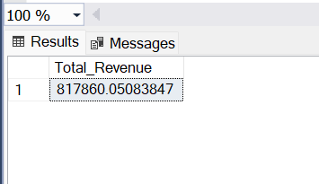

1. **Average Order Value**

SELECT sum(total_price)/ count(DISTINCT order_id) AS Avg_Order_Value from pizza_sales

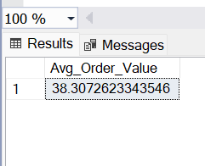

1. **Total Pizzas Sold**

Select sum (quantity) AS Total_Pizzas_Sold from pizza_sales

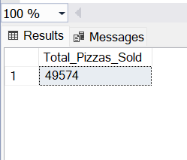

1. **Total Orders**

Select count(DISTINCT order_id) AS Total_Orders from pizza_sales

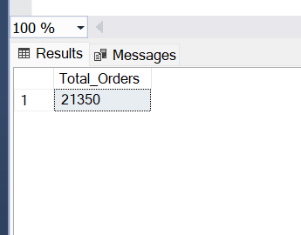

1. **Average Pizzas Per Order**

Select Cast(Cast(sum(quantity) AS DECIMAL(10,2))/Cast(count(DISTINCT order_id) AS DECIMAL(10,2)) AS DECIMAL(10,2))

AS Avg_Pizzas_Per_Order from pizza_sales

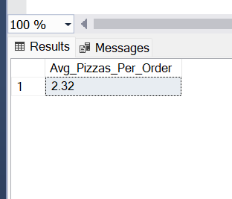

1. **Daily Trend For Total Orders**

Select DATENAME(DW, order_date) as order_day,COUNT(DISTINCT order_id)

As Daily_orders

from pizza_sales

Group By DATENAME(DW, order_date)

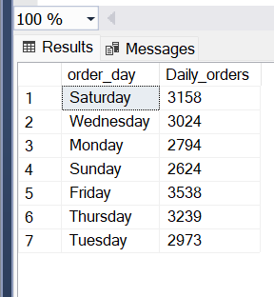

1. **Hourly Trend For orders**

Select DATEPART(HOUR, order_time) as order_hours, COUNT(DISTINCT order_id) as total_orders

from pizza_sales

Group BY DATEPART(HOUR, order_time)

order by DATEPART(HOUR, order_time)

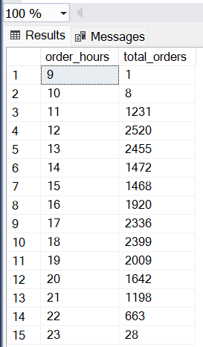

1. **% of sales by pizza_category**

Select pizza_category, Cast(SUM(total_price) as decimal(10,2)) as Total_revenue,

Cast(SUM(total_price)* 100/ (Select SUM(total_price) from pizza_sales) as decimal(10,2)) as PCT

from pizza_sales

Group BY pizza_category

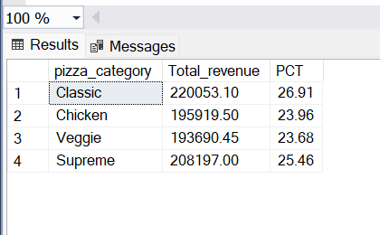

1. **% of sales by pizza size**

select pizza_size, Cast(SUM(total_price) as decimal(10,2)) as Total_Revenue, Cast(Sum(total_price)*100/ (Select SUM(total_price) from pizza_sales) as decimal(10,2)) as PCT

from pizza_sales

group by pizza_size

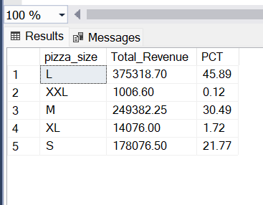

1. **Total Pizzas sold by pizza category**

select pizza_category, SUM(quantity) as Total_quantity_sold

from pizza_sales

where MONTH(order_date) = 2

group by pizza_category

order by Total_quantity_sold desc

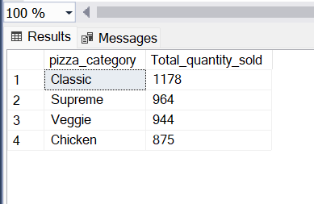

1. **Top 5 Best Sellers by Total Pizzas Sold**

select Top 5 pizza_name, SUM(quantity) AS Pizzas_Sold

from pizza_sales

group by pizza_name

order by Pizzas_Sold desc

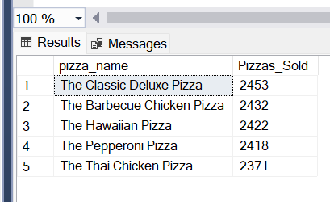

1. **Bottom 5 Best Sellers by Total Pizzas Sold**

select Top 5 pizza_name, SUM(quantity) AS Pizzas_Sold

from pizza_sales

group by pizza_name

order by Pizzas_Sold

